**Worksheet 1 – SUM, MIN,MAX, AVERAGE, Count**

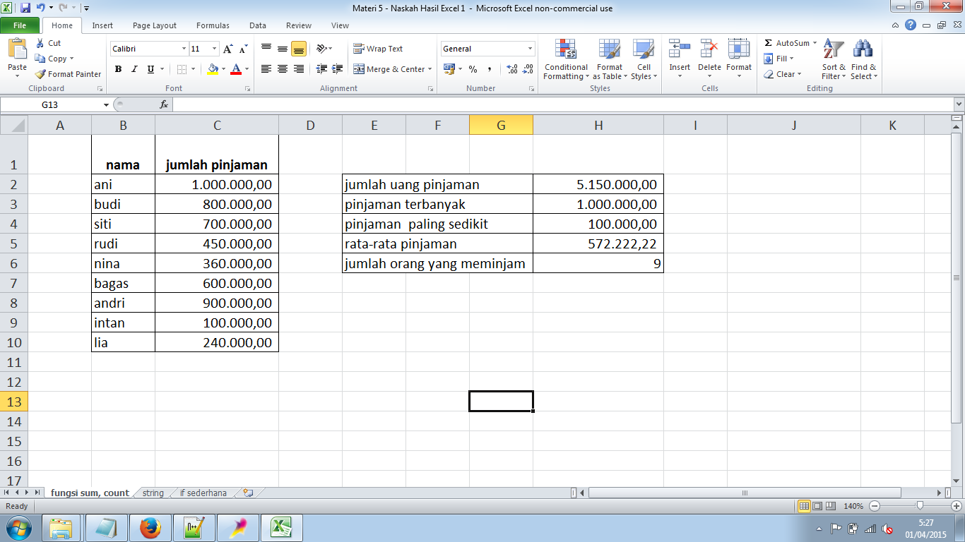

**Worksheet 2 - String**

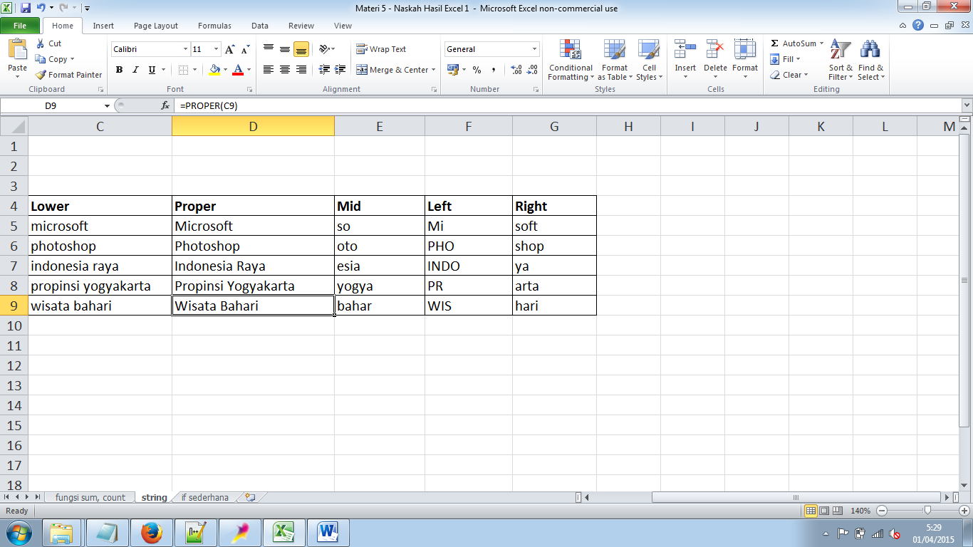

**WorkSheet 3 – If Sederhana**

